User Manual - ShareSomeArt

  - Matthew Miller, Abdinasir Aidrus, Larissa Allen, Haylea Engles, Ahmadou Diall,
  - Theodore Kaltsas & Joshua Graham
  - Franklin University
  - COMP 495
  - Prof. Yuying Wang and Prof. Brian Gorman
  - 11/23/2025

User Manual
Functionality: Login
Description: Users can log in to the website through a login screen to the one shown. They must either create a new account or sign in with the email and password of an existing account. An authentication filter is in place to prevent users from viewing any posts unless they are logged in.
Screenshot:
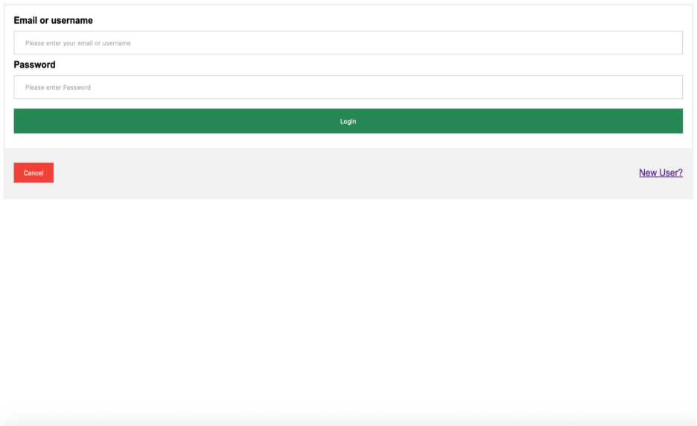

Functionality: Registration
Description: Users who don’t have an account can register for the application via a link on the log in page. During registration, users are required to provide a username, email, and password. All these fields undergo validation to ensure that no invalid data is submitted to the database. The registration page appears similar to the screenshot shown below.
Screenshot:
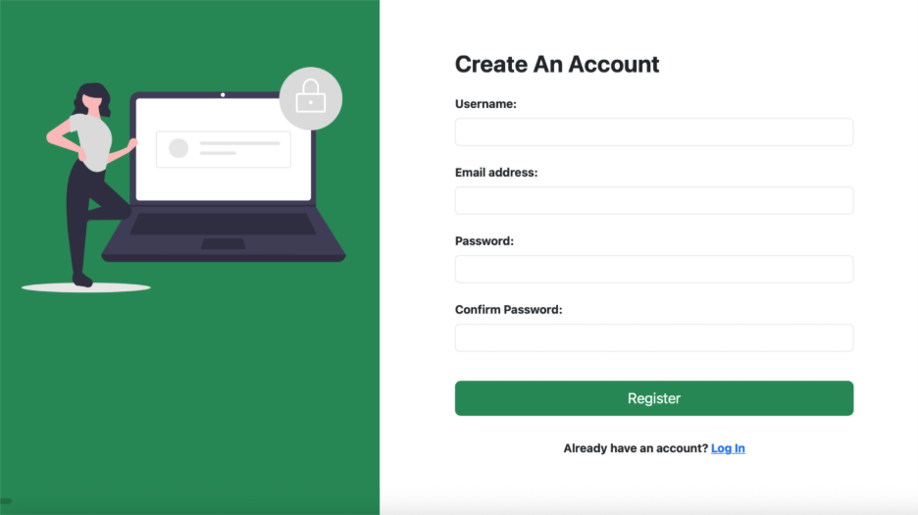

Functionality: Comment
Description: Users are able to add comments to posts within the application. When submitting a comment, they can enter text into a blank input field and post it. After a comment is posted, users also have the option to delete it. The application stores each comment along with its creation date. The backend service handles saving, retrieving, and removing comments and ensures that only valid comment IDs can be deleted.
Screenshot:
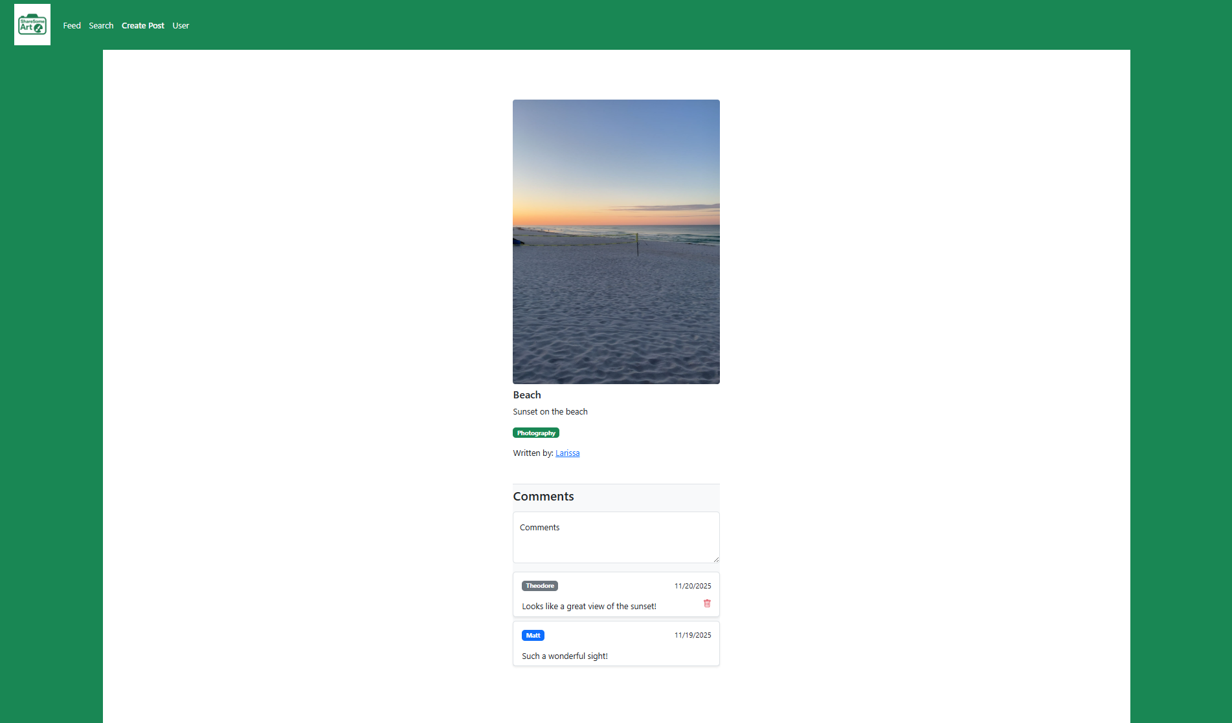

Functionality: Edit Post
Description: Users can edit any post they created. When the edit page opens, the form is filled with the existing title, description, tag, and image so they can make changes without starting over. All fields in the edit page are optional, and if the user does not upload a new image, it still uses the original picture. After the form is submitted, the updated information is sent to the backend to be checked and saved. If the update is successful, the user is taken back to their profile page. If something goes wrong while editing the post, then an error message will appear.
Screenshot:
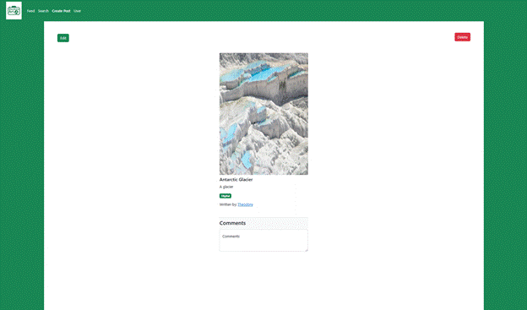
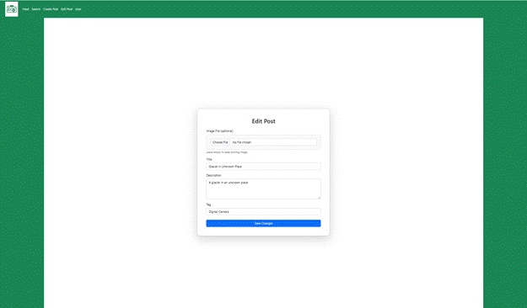
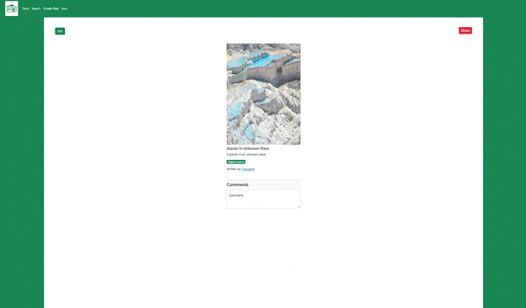

Functionality: Delete Post
Description: Users can delete any post they created. When they choose to delete a post, the request is sent to the backend with the id of the post. The backend finds the post and marks it as hidden instead of removing it completely. After this change is saved, the post no longer appears on the feed of the user. If the delete works, the user is taken back to their profile page. If something goes wrong while attempting to delete a post, then an error message will appear.
Screenshot:
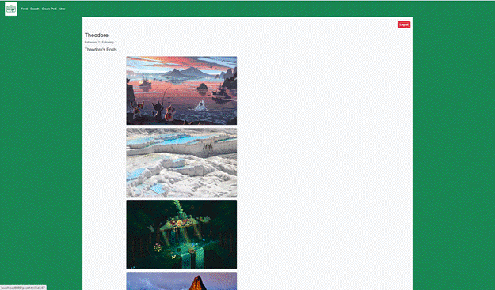
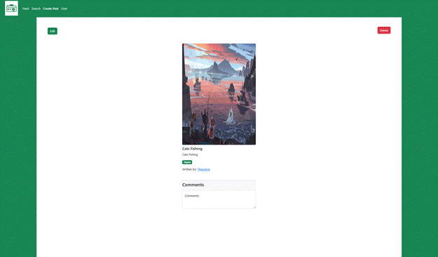
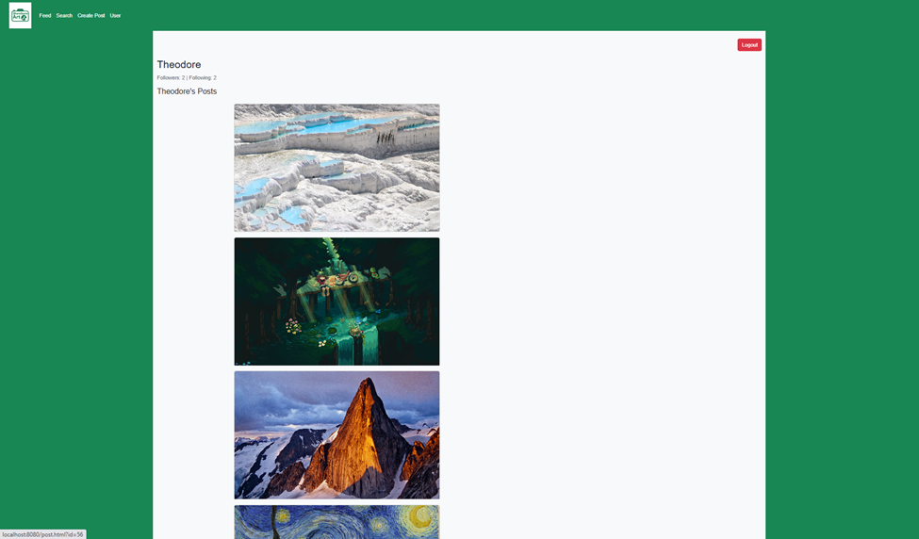

Functionality: Create Post
Description: Users can create new posts in the application by uploading an image file and providing a title, description, and tag. The application validates that no empty data is submitted and provides a user-friendly error message if a field is missing. The post data is sent to the backend and stored. Once created, the user is redirected back to their user page where the new post is visible.
Screenshot:
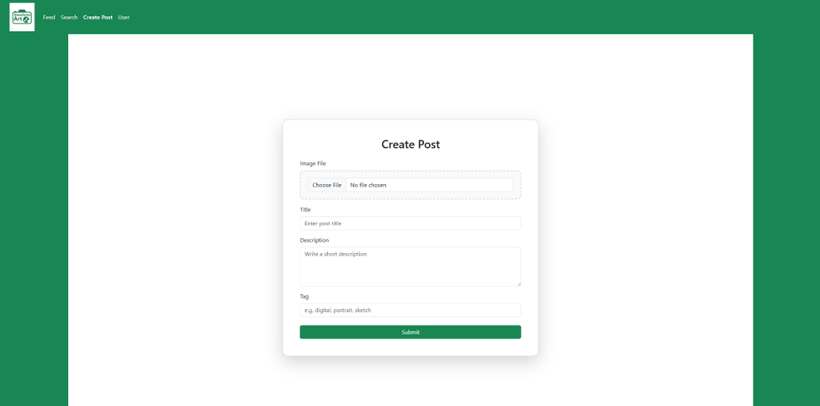

Functionality: User
Description: Displays the current logged in user’s profile. The application retrieves the users’ details from the backend and that information is displayed on the page. This includes their username and both their following and follower count. In the upper right there is a logout button. Below it displays thumbnails of all the users posts which are linked to see the rest of the post’s information.
Screenshot:
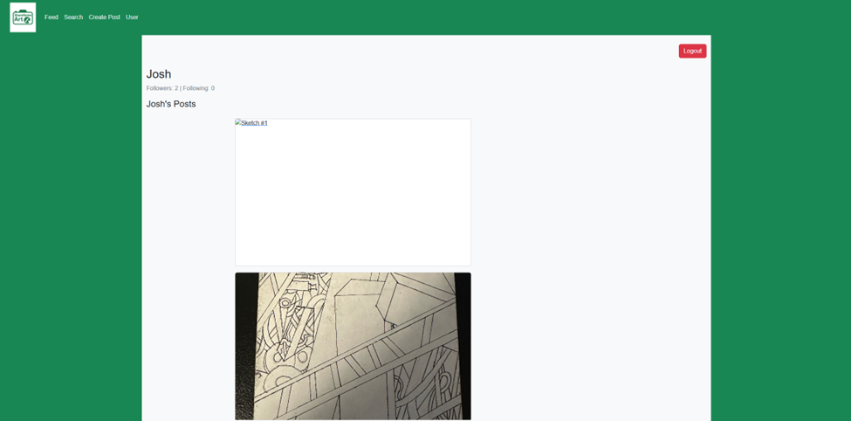

Functionality: User Public Page

Description:
This page shows the profile of another user in the app. You can see their username, how many people they follow, and how many followers they have. Under that, their posts will appear in a grid. This page only lets you view their content; you cannot edit anything here. You can look through their posts and click on any card to open the full post.

Screenshot:
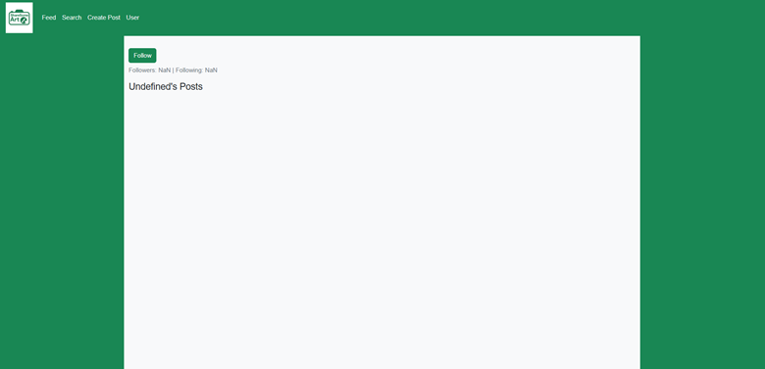

Functionality: Follow / Unfollow

Description:
The follow button lets you follow another user. When you press it, it changes to an unfollow button. Following someone adds their new posts to your feed. If you decide to unfollow them, you can press the button again and it will switch back.

Screenshot:
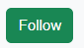
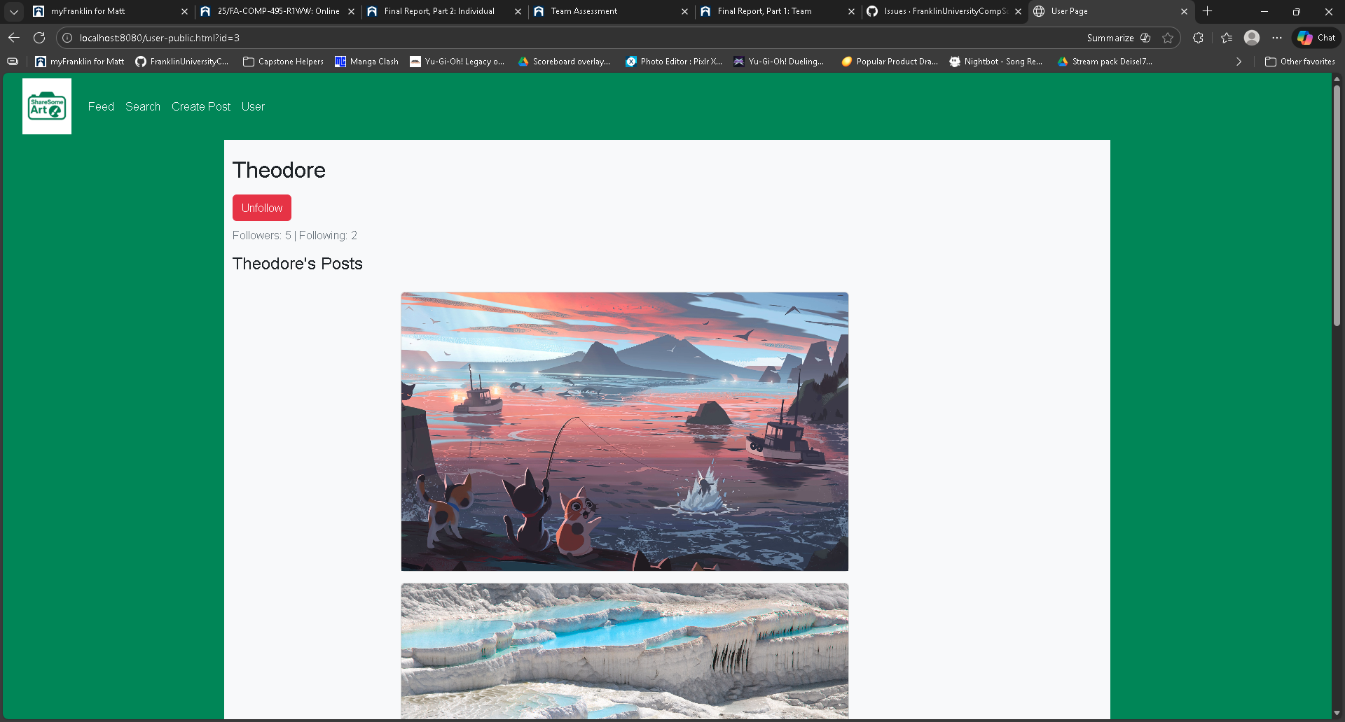

Functionality: Image Card

Description:
Image cards are the small previews that show each post across the app. Each card includes the post image along with the title and tag. Clicking a card opens the full post page so you can read the description and see comments. These cards are used on pages like the feed, search results, and user profiles to help users quickly browse posts.

Screenshot:
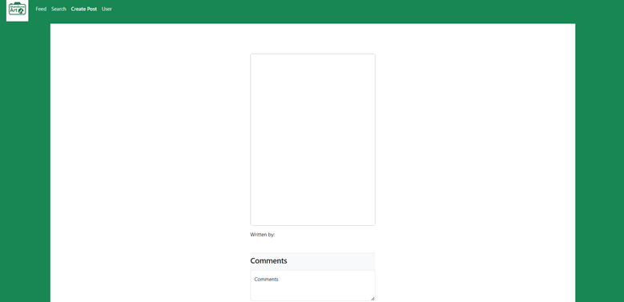

Functionality: Logout
Description: Users can log out of the application by clicking on the logout button on their user page. When pressed, the application sends a request to the backend to terminate the current session. If successful, the user is redirected back to the login page. This prevents unauthorized access and allows for switching accounts easily.
Screenshots:
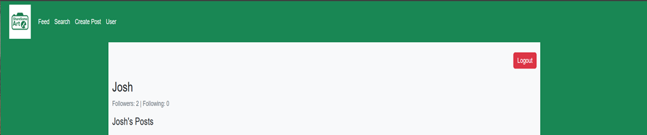

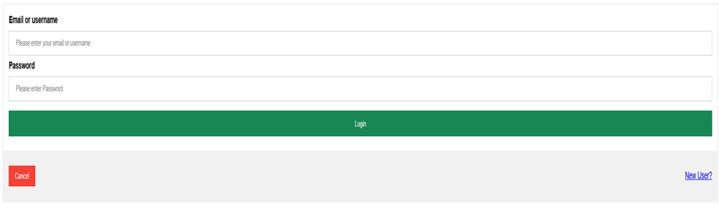

Functionality: Feed
Description: The feed page displays posts from users that the logged in user follows. When a user signs in, the system retrieves posts created by the accounts they follow and shows them together in a single, scrollable feed. The page updates automatically whenever new posts are created by followed users.
Screenshots:
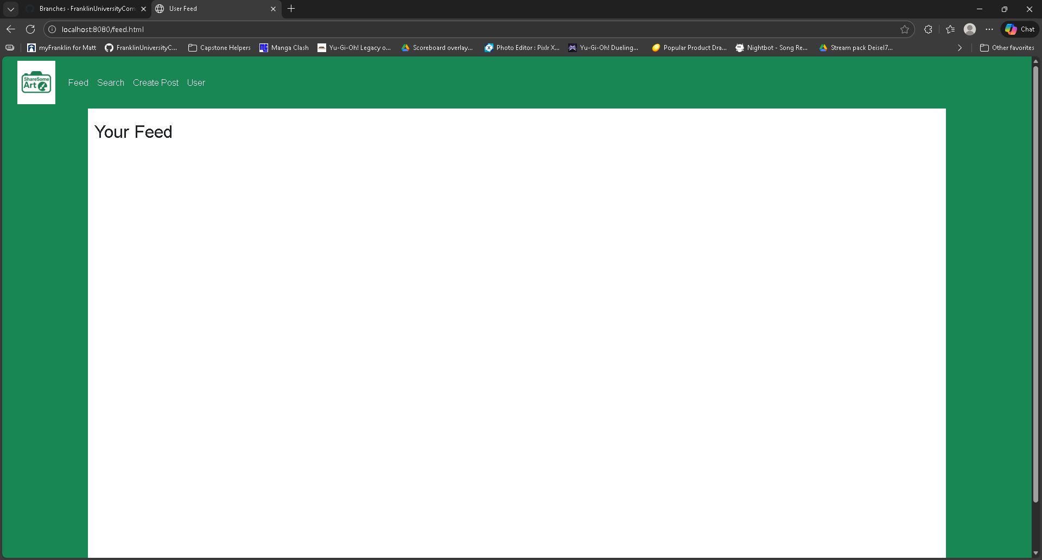
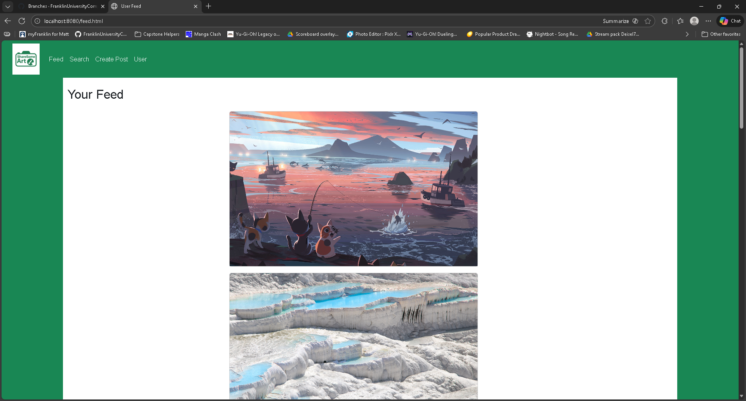

Functionality: Search
Description: Users can search for content on the website by selecting a search type and entering a keyword. The search page supports three options, Tag, Title, and User. After the user selects a type, enters a keyword, and clicks the search button, results appear as clickable links on the left side of the page.
Screenshots: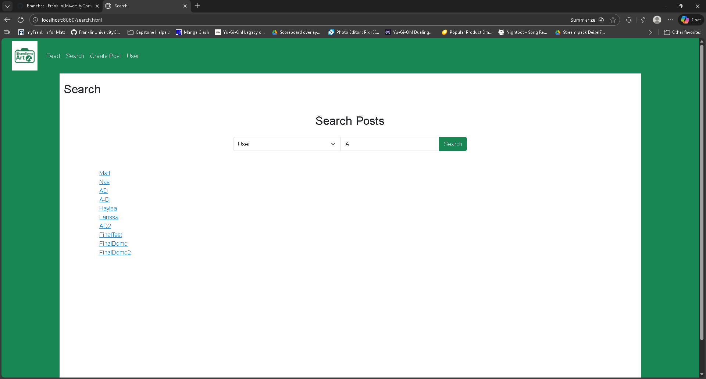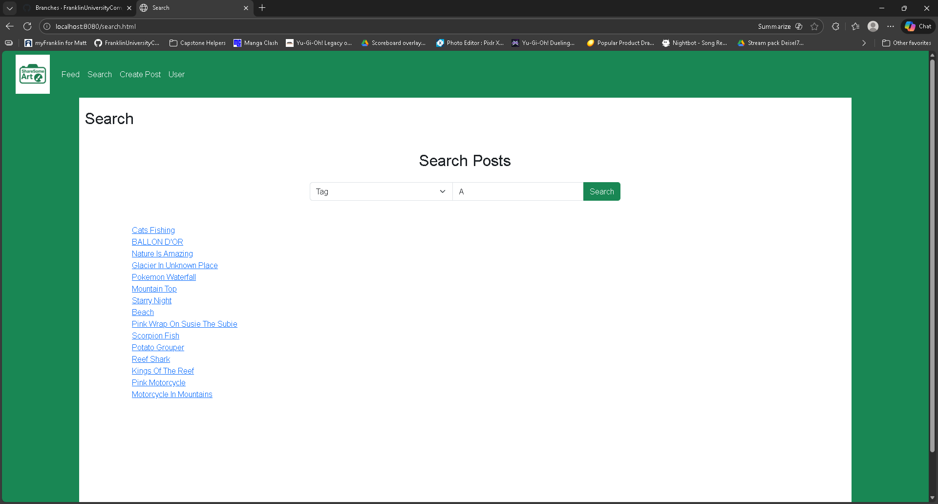
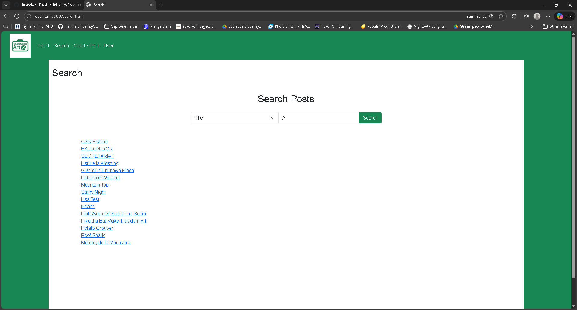

Functionality: Post
Description: The posts page displays the complete details of a selected post, including its image, title, description, tag, and the user who created it. When a user opens a post, the system retrieves the post information by its ID and displays it on the page. Logged in users can also write comments on the post, and any existing comments are shown below the post details along with the commenter’s name and the date the comment was written.
Screenshots: